Assignment 1

Problem 1: Read the instructions carefully and answer accordingly. If there is

any need to insert some data then do that as well.

a) Navigate and List:

a. Start by navigating to your home directory and list its contents. Then, move into a

directory named "LinuxAssignment" if it exists; otherwise, create it.

Ans: for navigating home directory we can use following command cd or cd ~ : it used show back to home directory from anywhere in the directory. for listing the content we can use following command: ls : it list the content. first create the directory by using following command: mkdir LinuxAssignment if already exitsts then directly move to this directory by using following command: cd LinuxAssignment

Output: 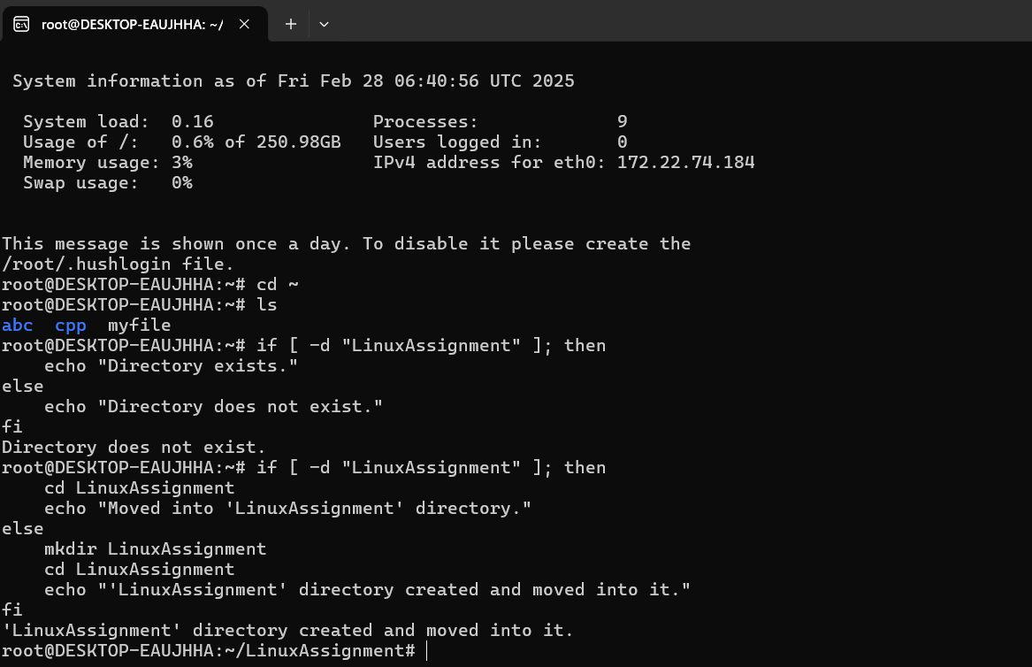

b) File Management:

a. Inside the "LinuxAssignment" directory, create a new file named "file1.txt". Display its

contents.

Ans:

first we can check present working directory by using pwd command

after that if we are not in LinuxAssignment directory then we can directly write

cd LinuxAssignment command to move that directory.

for creating a new file there is so many options like touch,cat,nano,vi editor etc.

we can create file using any one comand which we want

Touch is create empty file.

cat is used to create file as well as contentof file but we cannot modify.

in nano & vi editor we can create as well as modify the data.

Output:

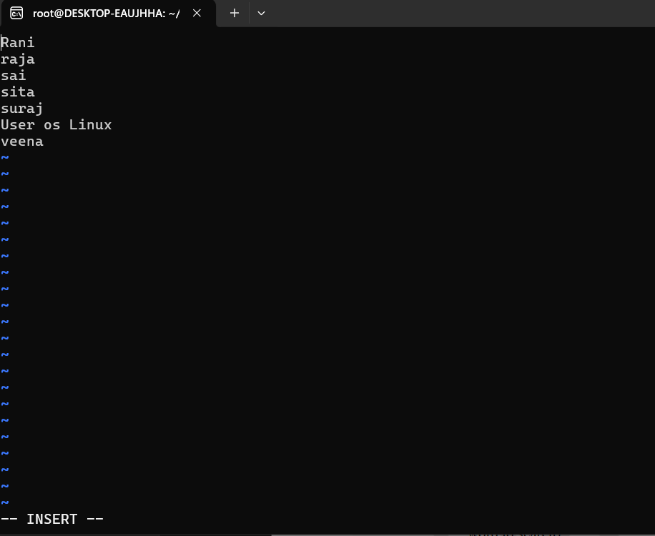

c) Directory Management:

a. Create a new directory named "docs" inside the "LinuxAssignment" directory

first we can check present working directory by using pwd command

after that if we are not in LinuxAssignment directory then we can directly write

cd LinuxAssignment command to move that directory.

create the directory by using following command:

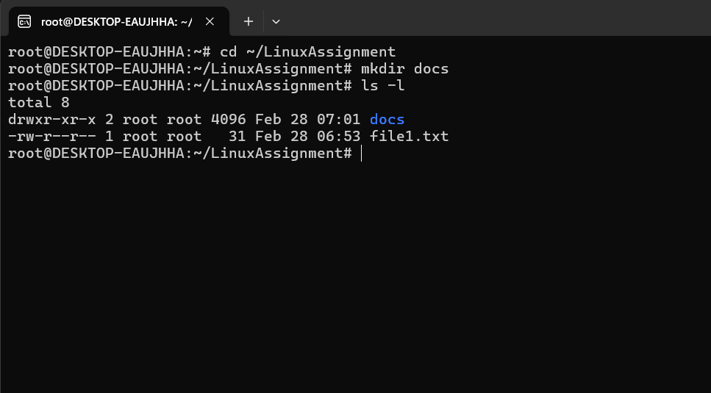

d) Copy and Move Files:

a. Copy the "file1.txt" file into the "docs" directory and rename it to "file2.txt".

output:

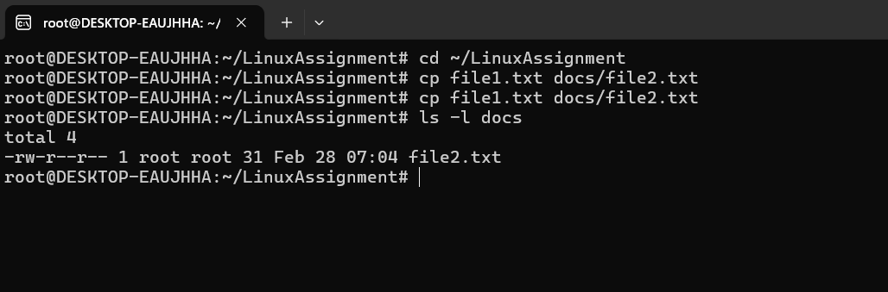

e) Permissions and Ownership:

a. Change the permissions of "file2.txt" to allow read, write, and execute permissions for

the owner and only read permissions for others. Then, change the owner of "file2.txt" to

the current user.

Output:

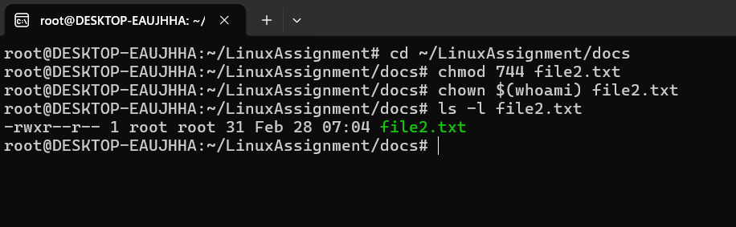

f) Final Checklist:

a. Finally, list the contents of the "LinuxAssignment" directory and the root directory to ensure that all operations were performed correctly.

ls -1 ~/linuxassigment

This command lists all files and directories in the "LinuxAssignment" directory with detailed information, including permissions, ownership, size, and modification date.

ls -l /

1. This command lists all files and directories in the root directory with detailed information.

These commands will help you confirm that the "LinuxAssignment" directory contains the expected files and that the root directory is as expected.

Output:

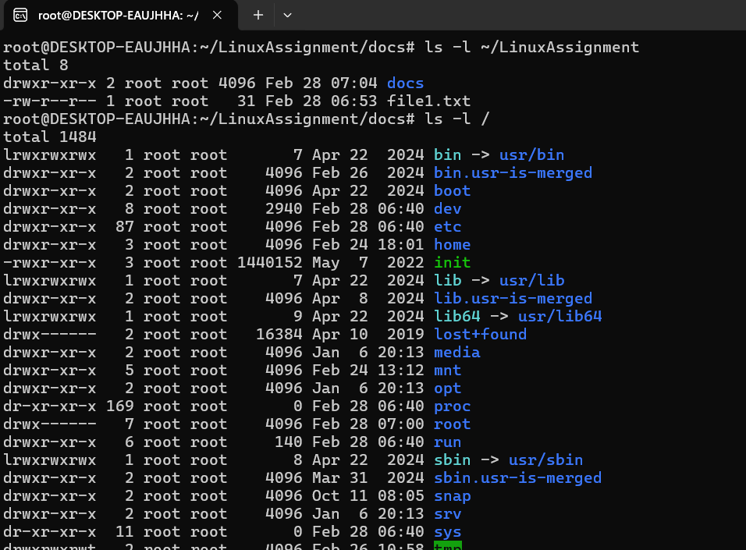

g) File Searching:

a. Search for all files with the extension ".txt" in the current directory and its subdirectories.

b. Display lines containing a specific word in a file (provide a file name and the specificword to search).

Ans:

* Use the find command to recursively search for all .txt files:
* To search for lines containing a specific word in a file, use the grep command:
* find lines containing the word "example" in a file named "document.txt":
* you want to search for the exact word (not as part of another word), use the -w option:
* o search for a word that includes special characters (like a dot), escape the character with a backslash:

Output:

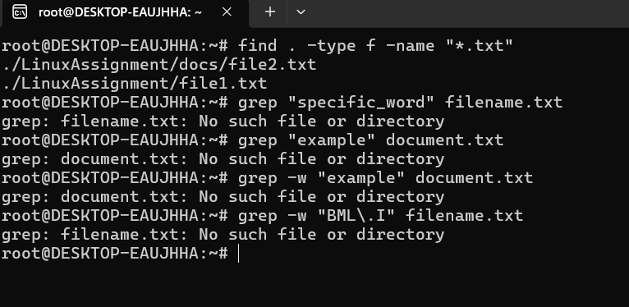

h) System Information:

a. Display the current system date and time.

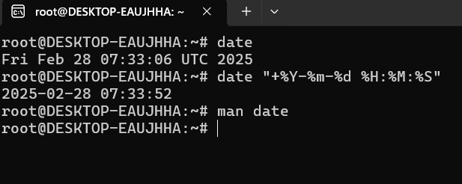

Networking:

a. Display the IP address of the system.

b. Ping a remote server to check connectivity (provide a remote server address to ping).

Output:

a.

To display Ip address of system we can use hostname -i command

b.

ping command is used to check remote server is running or not

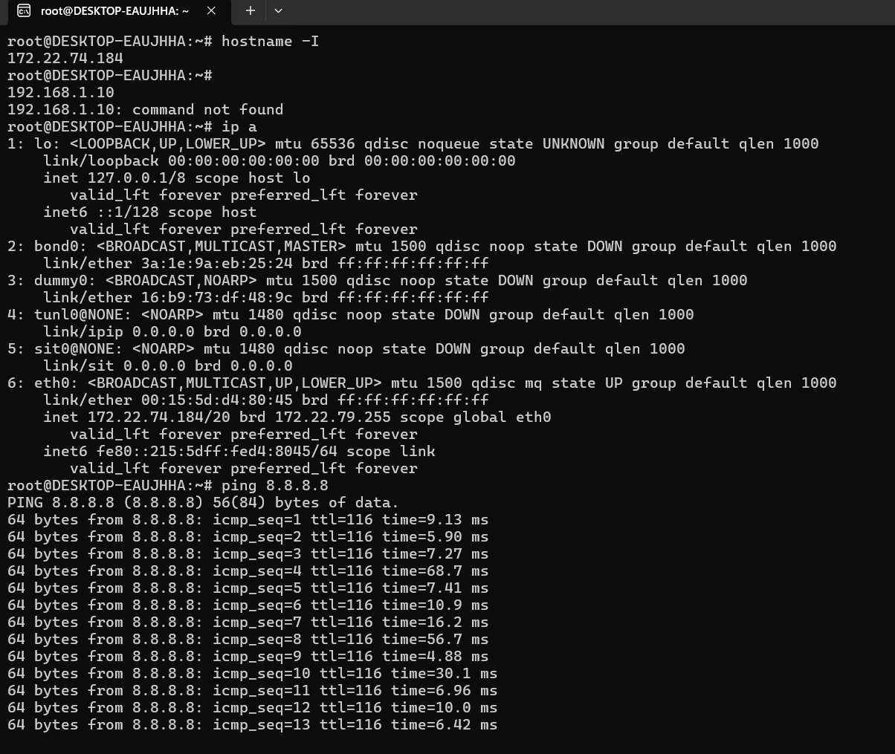

j) File Compression:

a. Compress the "docs" directory into a zip file.

b. Extract the contents of the zip file into a new directory.

Output:

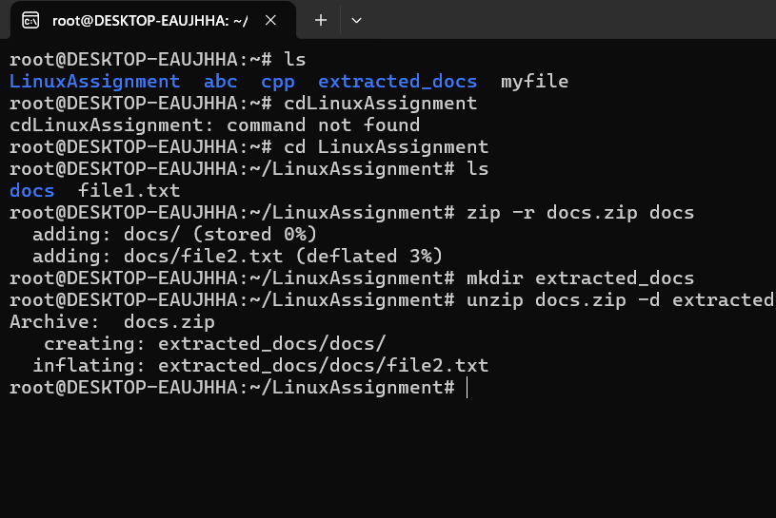

k) File Editing:

a. Open the "file1.txt" file in a text editor and add some text to it.

b. Replace a specific word in the "file1.txt" file with another word (provide the original word and the word to replace it with).

Output

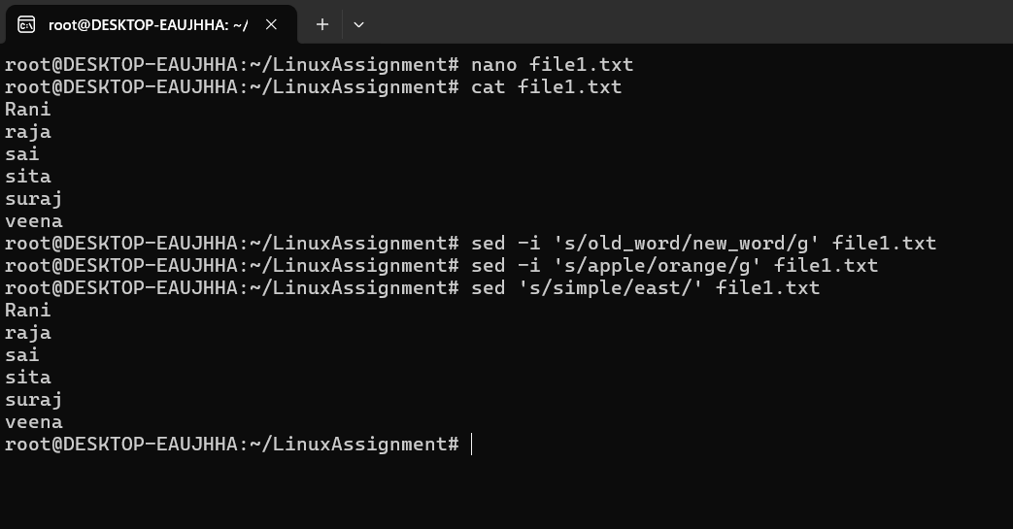

Problem 2: Read the instructions carefully and answer accordingly. If there is any need to insert some data then do that as well.

1. Suppose you have a file named "data.txt" containing important information.

Ans: first 10 lines of this file to quickly glance at its contents using a command

1. Display the first 10 lines of this file to quickly glance at its contents using a command.

Ans:by using head command we can print first 10 lines.

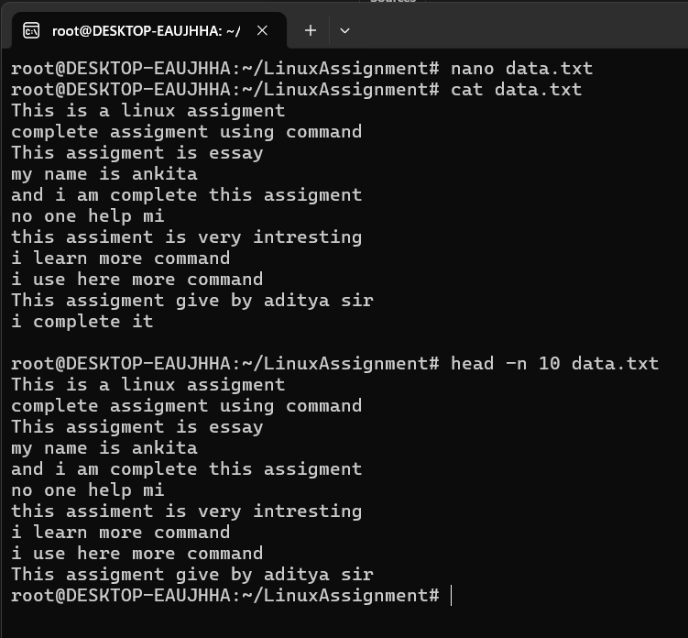

b. Now, to check the end of the file for any recent additions, display the last 5 lines of

"data.txt" using another command.

Output:

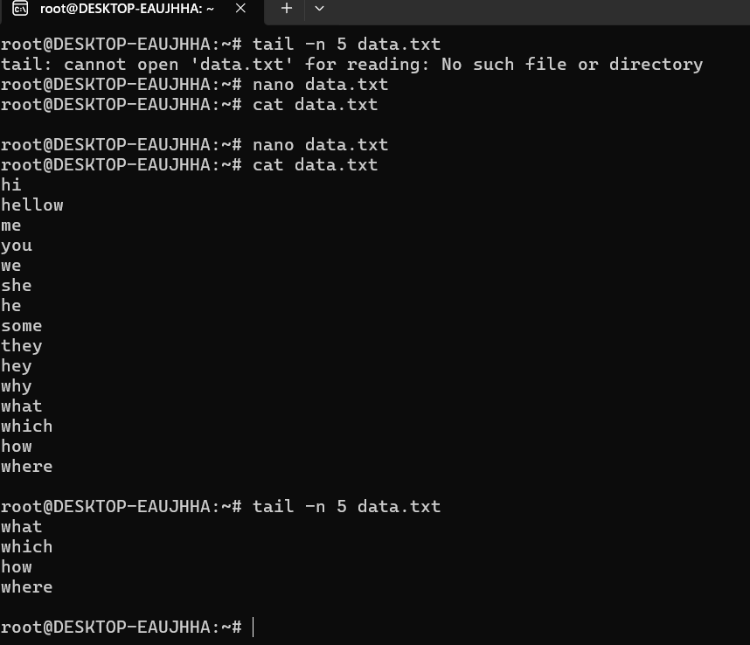

1. In a file named "numbers.txt," there are a series of numbers. Display the first 15 lines of this file to analyze the initial data set.

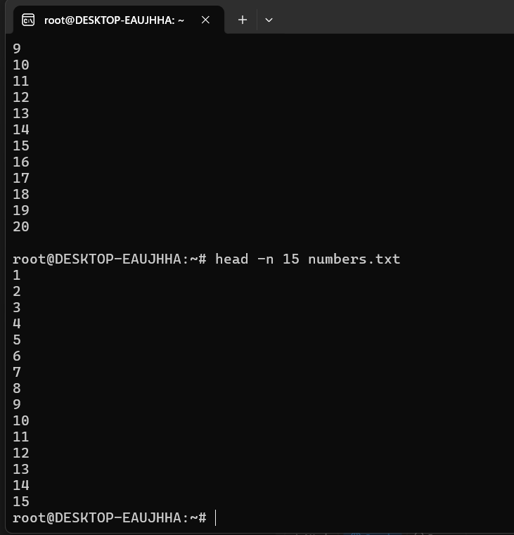

d. To focus on the last few numbers of the dataset, display the last 3 lines of

"numbers.txt".

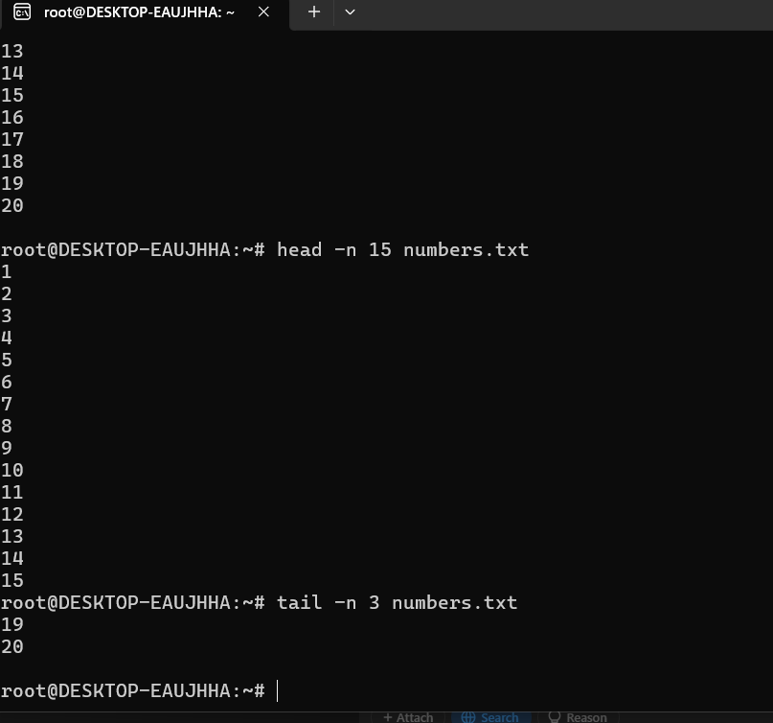

1. Imagine you have a file named "input.txt" with text content. Use a command to translate all lowercase letters to uppercase in "input.txt" and save the modified text in a new file named "output.txt."



1. In a file named "duplicate.txt," there are several lines of text, some of which are duplicates. Use a command to display only the unique lines from "duplicate.txt."

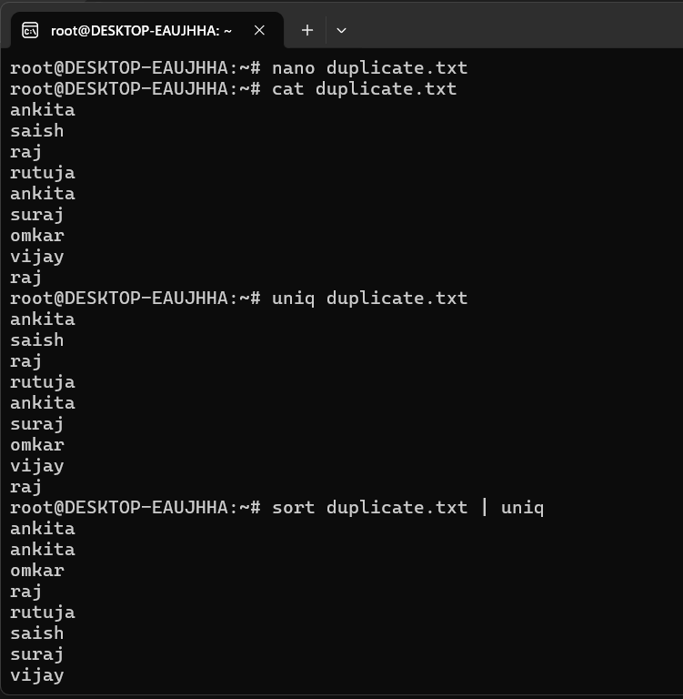

g. In a file named "fruit.txt," there is a list of fruits, but some fruits are repeated. Use a

command to display each unique fruit along with the count of its occurrences in

"fruit.txt."

Output

